CURRICULAM VITR

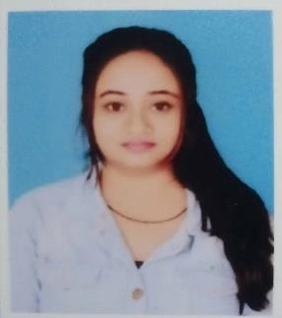

# ACADEMIC QUALIFICATION

## ANAMIKA KUMARI

|  |  |  |  |
| --- | --- | --- | --- |
| **NAME** | **10th** | **12th** | **B.A** |
| **SCHOOL / COLLEGE** | ST. STEPHEN SCHOOL HAZARIBAG | JHARKHAND COLLEGE DUMRI | ANANDA COLLEGE HAZARIBAG |
| **FROM** | C.B.S.C | J.A.C | J.A.C (V.B.U) |
| **SUBJECT** | - | SCIENCE | ARTS  (ENGISH) |
| **DIVISION** | 1ST | 1ST | 1ST |
| **YEAR** | 2017 | 2019 | 2022 |
| **%** | - | 60% | - |
| **C.G.P.A** | 9.0 | - | 6.73 |

## CONTACT NUMBER

Mobile :- 6206906425

E-mail id :- [mistydolly1712@gmail.com](mailto:anamikadolly1712@gmail.com)

## ADDRESS :

Konar canal division bagodar

PO :- Bagodar

District :- Giridih

PIN Code :- 825322

State :- Jharkhand

**COMPETNCIES**

self confidance

fast learner & leadership

**PERSONAL DETAILS**

FATHER’S NAME:-SHRI SANJEEVKUMAR

MOTHER’S NAME:- SHIRIMATI ARTI DEVI

CATOGARY :- OBC

D.O.B :-17/12/2002

SEX :- FEMALE

NATIONLITY :- INDIAN

HOBBIES :- READING & COOKING

**OTHER QUALIFICATION**

ADVANCE DIPLOMA IN COMPUER APPLICAION

good presenation skills

working capacity

**DECLARATION**

**DECLARATION**

“I hereby declare that all the statement made

above are ture to the best of my knowledge.”

Singnature :-

**COMPETNCIES**

* self confidance
* fast learner & leadership
* good presenation skills
* working capacity
* challenging environment

Singnature

**LANGUAGE KNOWN**

HINDI , ENGLISH